***LINUX COMMANDS: EXERCISES 1 -13***

**\*\*Commented in class: -d** before a letter selection (for example **a\***) is done for directories (but without showing its contents **). In some of these exercises it is valid, as we have proved its functioning, but I am removing them so that my exercises are as correct as possible.

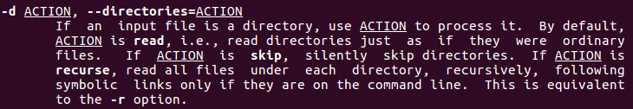

1. We need to use **<cd $HOME>**, but we should have that directory as default, so we can just type **<pwd>** and, if we are already there, keep on with our work.

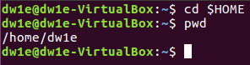

1. We have to write **<mkdir (directory_name)>**  (directory_name → systems)



1. First we have to create the “exercises” directory by typing **<mkdir exercises>**, then access it (**<cd exercises>**) and create inside it a new directory called “programming” (by typing **<mkdir programming>**).

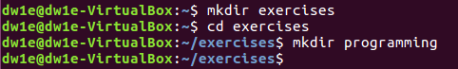

1. To remove “exercises” directory having “programming” directory in it, we will need to go to our “home” directory (typing **<cd ..>**, as we located in “exercises”) and then type **<rmdir -p exercises/programming>**, which will delete both directories.



Then we need to create these directories again but **with 1 command**, so we will type **<mkdir -p exercises/programming>** to create both with this command.



1. To list all the files in the “root” directory, the easiest way is the following: locate ourselves in the “root” (**<cd />**)) and we type **<ls>** (or even **<ls -ls>** to see them listed in block size and with some data shown) sto see all the files will be displayed.



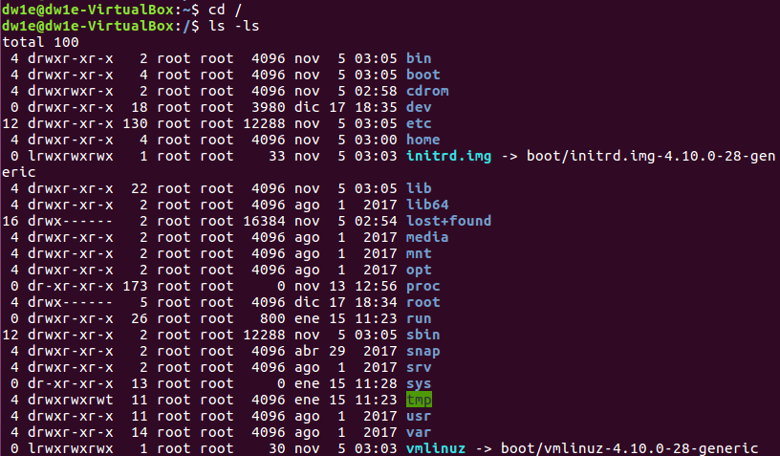

1. To list all the directories and files starting with “d”, in /usr/bin, we will have to be located in this directory by typing **<cd /usr/bin>** (we can do it inside or outside “root”). Once there, we will need to type **<ls d*>**  (“d*” to establish “d” as the first letter), and every file or directory starting with “d” will appear.

******We can also do it directly (without locating) by typing **<ls /usr/bin/d*>\*\*\*\*\*\*\***

****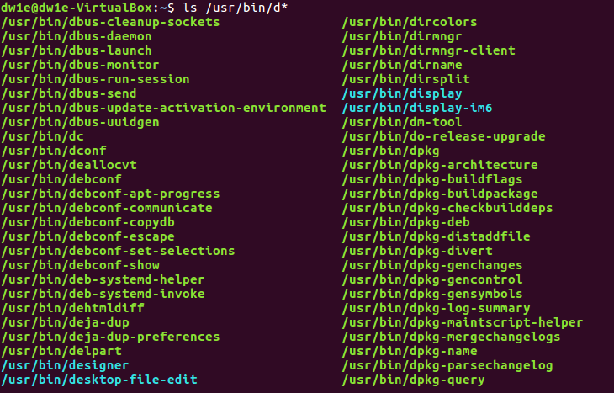

(and lots of lines below...)

1. To show all the directories and subdirectories, the command we need to use is **<ls -R>** and then add “/etc” to refer to the place from which we want to see the directories: **<ls -R /etc>**

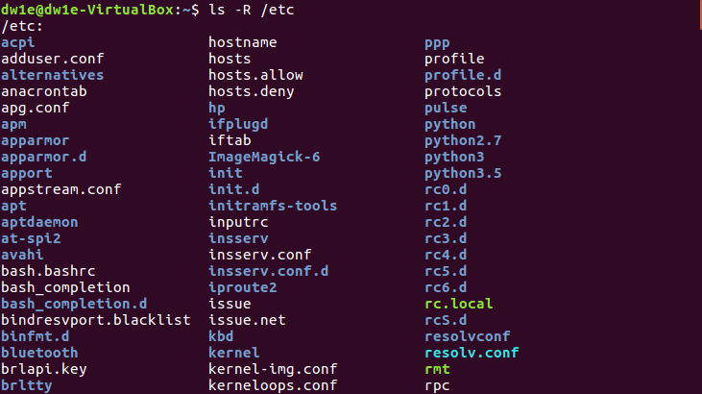

(and lots and lots of lines below…)

1. To create these files in “systems” we need to type **<cd systems>** to locate inside it and then use“touch” to create the files. We will do it with 1 command: **<touch student.txt student1.txt student2.txt list luggage last>**

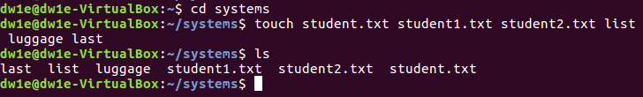

1. To list the files that start with “l” in “systems” we will have to type **<ls -d l*>**



CORRECTION: here better not to use **-d**, even though it still works. **→ <ls l*>**

1. To list all the files that finish with “txt” in “systems” we will have to type **<ls -d *txt>**

CORRECTION: here better not to use **-d**, even though it still works. **→ <ls l*>**

1. To create a new directory in “home” we will have to go back to it (typing **<cd ..>** (as we are in “systems”)) and create the new one, called “config” (**<mkdir config>**).



1. In order to copy all the elements from “etc” which start with “a” we need to type **<[sudo] [cp -R] [/source/letter*] [/route/reciever_directory]>**, so in this case: **<sudo cp -R /etc/a* /home/dw1e/config>** (“sudo” will be needed to have permission // “etc” is the directory we want to copy the files from // “dw1e” is the user in this case)



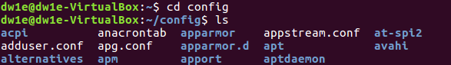

1. Finally, remove all the files finishing in “conf” we need to type **<rm -f *conf>**





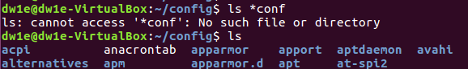

We can also use **<rm -i *conf>**, whose difference is that some warnings will appear.

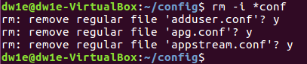

**ALFREDO PUERTA GALLEGO DW1E**